Project Description:

For my DH 150 Project, I am prototyping an app that will engage the Korean entertainment community. The main users will be people aged 13-25, mainly consisting of students. The app will serve as a news feed of the latest Korean entertainment news, and also have a community aspect to it, where people will be able to have a highly personalized experience if they engage with the platform. The app can support users to follow content they like, save articles for later, comment on content, share content via social media, and engage in forums. The main design focus of this app will be minimalism and conciseness, which can be achieved by using an organized interface and concise icons in place of excess text.

Some comments about this assignment:

* The scenarios in Assignment 5 have some overlap. The repeated activity would be bookmarking tags and seeing them in the “My Fave” tab. For the purpose of this assignment, I have chosen to focus more on Brandon’s task of engaging in a forum in order to avoid repetition in this assignment. I have also decided to focus on Amy’s commenting to show a more diverse prototype.
* I also asked the user to use two highlighters to mark up the prototype according to his understanding of the wireflow.
  + **Blue:** to indicate button clicked/interactions
  + **Pink:** which app tab the user is on.

To test my wireflow and prototype, I had my brother as a user to test it. I asked him to pretend that he was performing the tasks himself and comment on any flow or interaction that didn’t make sense user-experience wise. I have recorded his feedback per task as well as additional points I realized myself that I can improve for the next prototype.

General feedback regarding overall layout:

1. Better to have icons/symbols instead of titles for each tab, especially since the app should be as clear as possible to be mobile-friendly.

**Revision(refer to image attached)**

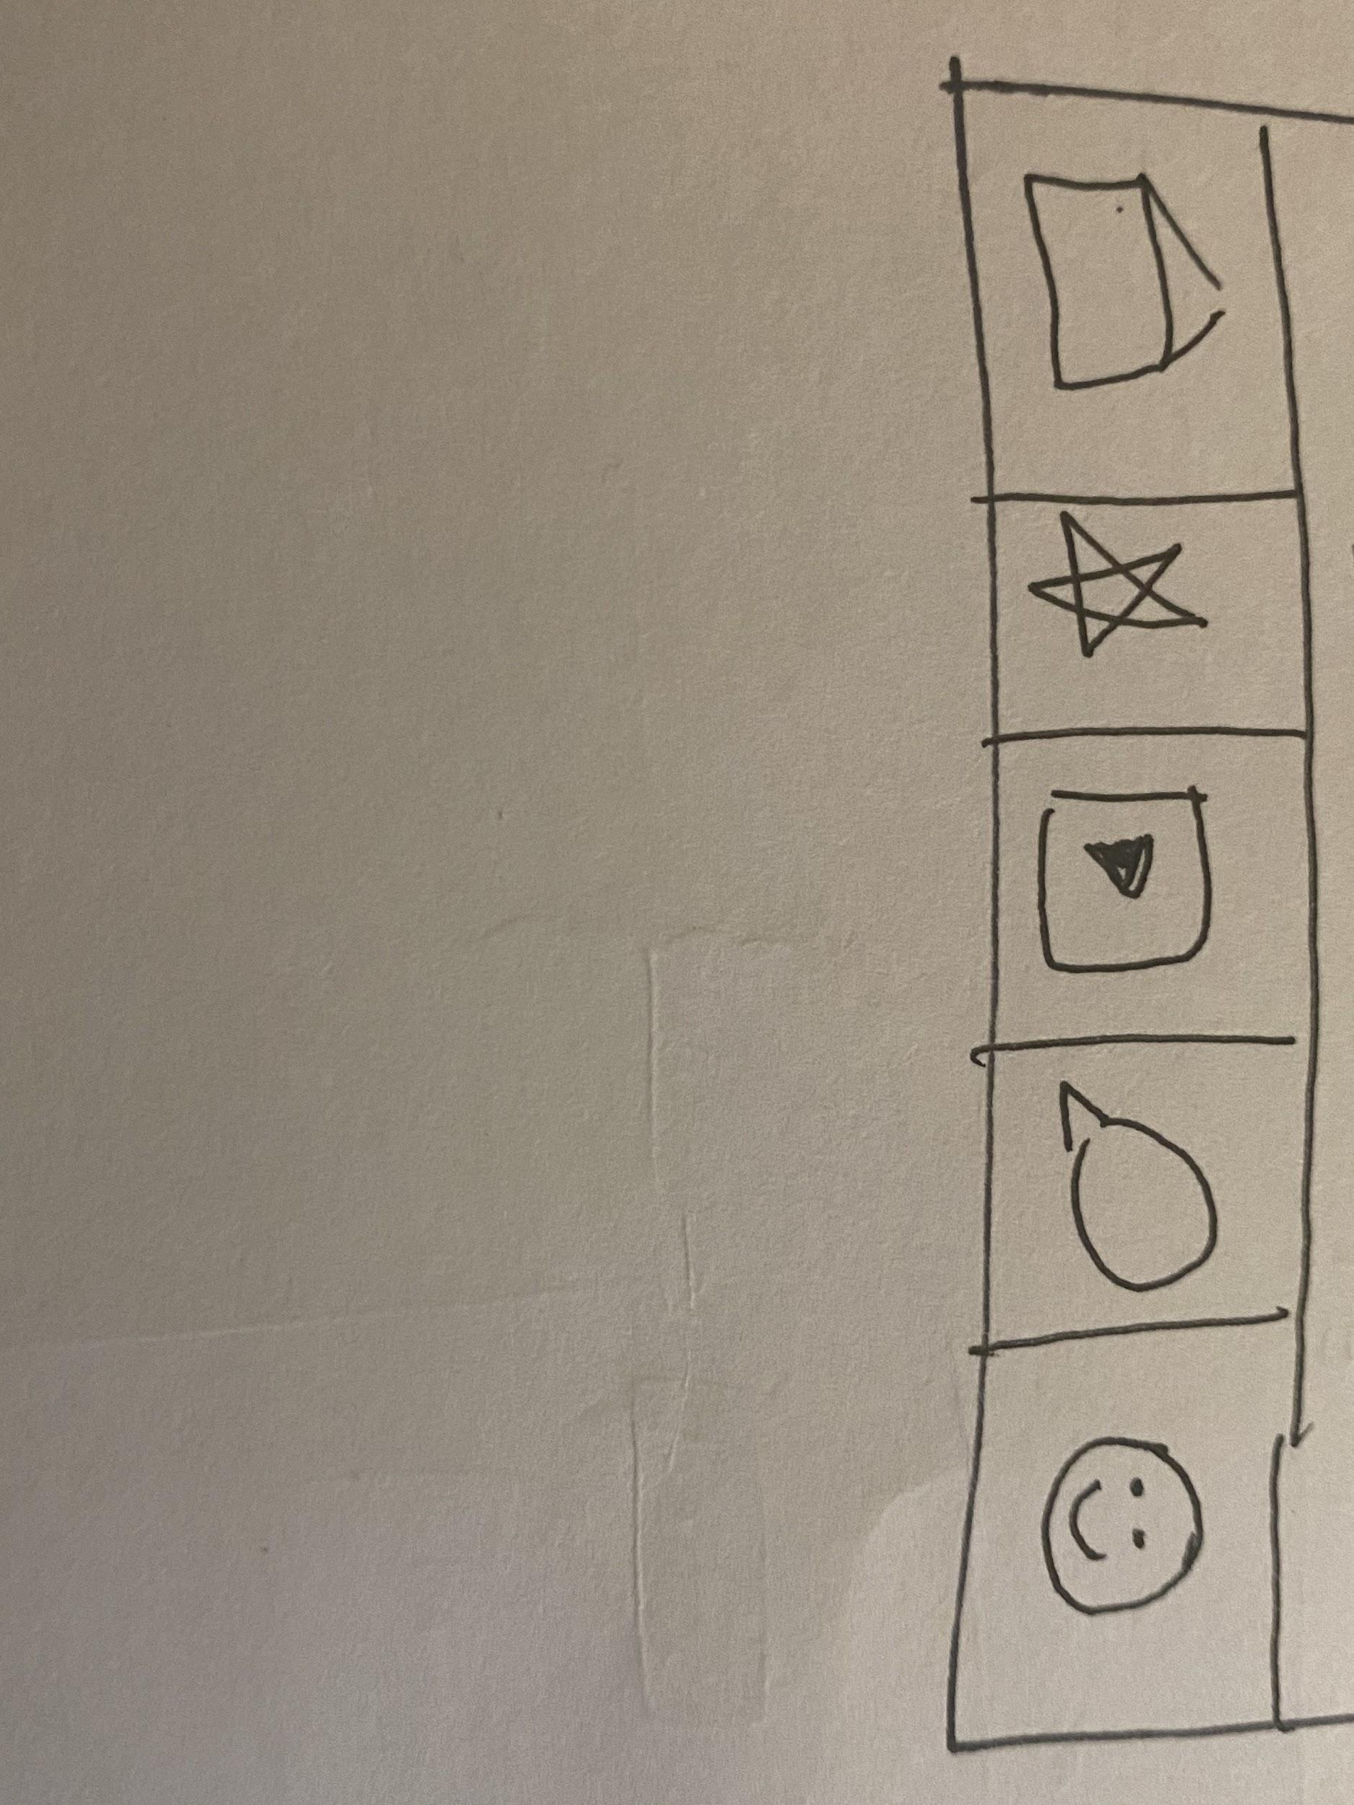

1. The plus sign on the welcome back screen is unnecessary. The user didn’t understand what the symbol was there for initially.

**Revision:** The plus icon to suppose to be a button for the user to click on if he/she is i interested in the recommended article. Replace the plus icon with an arrow. The plus icon is a little misleading because it seems to infer adding an image or file.

Task 1: Engage in a forum

Scenario background: Brandon proceeds to click on the forums page, which made him instantly feel unengaged. The forum interface looks boring with its grey and black color scale and uninteractive. There was no social media or feedback (like/dislike) component, that would facilitate interaction. The headers in the forum makes no sense to Brandon, and there is no way to filter/search for a forum. Instead, the only option to navigate the forums interface was either by scrolling all the way down, or moving onto the next page. Brandon was looking forward to seeing more social media elements in the community forum, since he is looking to get more involved in the community.

Feedback:

1. There should be a wireframe showing the screen when the user unsubscribes to a forum. (Currently, I only have a screen showing what would happen if a user joins a forum.)
   1. **Revision**: Add the option to unsubscribe\leave a forum. Include a pop up message to double check the user wants to leave the forum. “Are you sure you want to leave this forum?” with a Yes or No button.
2. It would make more sense if the user’s forums were shown in the Forums tab landing page, and not under “My Fave”. (wireframe #1)
   1. **Revision**: Remove “My Forums” under “My Fave” tab, and redesign it to be the opening page of the “Forums” tab. When a user logs into the app with his account and clicks on the Forums page, he will see his forums listed on top of the page, after the search bar.

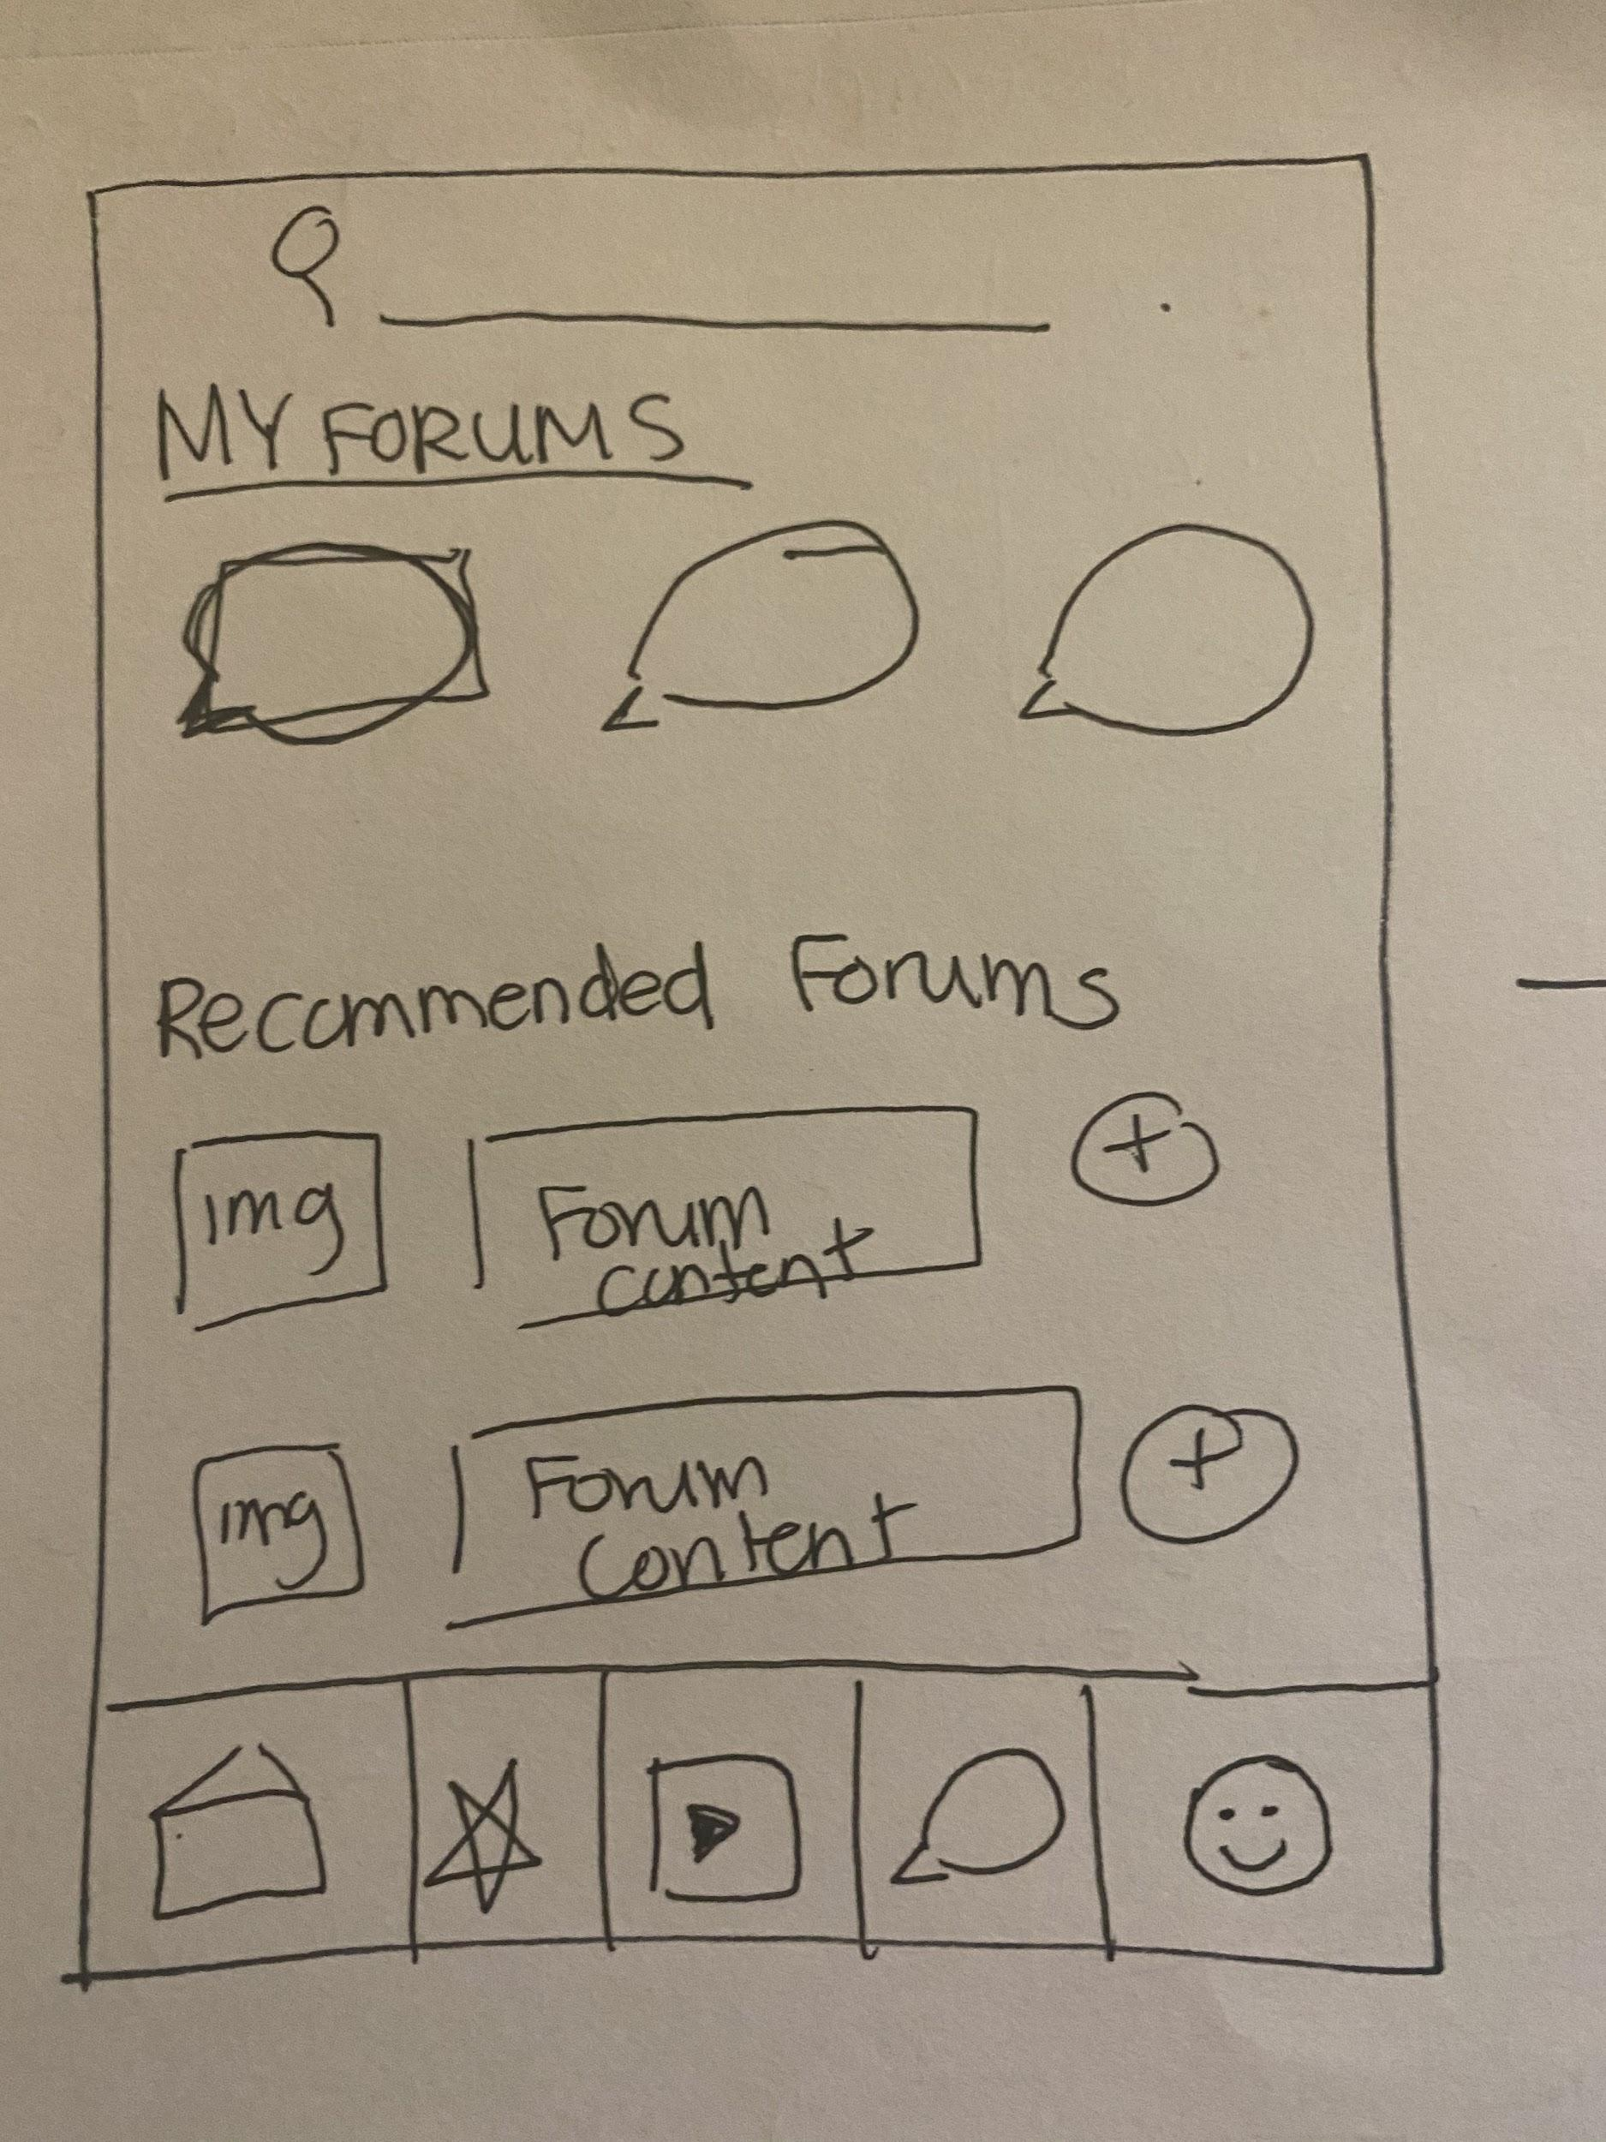

Task 2: Comment on a page

Once Amy finishes reading an article, she will gauge the community’s opinions through reading the comments underneath the article. She will also post her own opinions, by clicking into the comment bar. The system will prompt a chatbox to remind her that only registered accounts can comment. She will feel unprepared, and proceeds to make an account with the website. She is happy to find that she can proceed to commenting and engaging in forums after she logs in with her newly-made account. Amy finds out that she can also save the article for future viewing!

Feedback:

1. Wireframe 1 did not make sense because we are trying to show that Amy needs to register and log in to an account to comment on an article.
   * **Revision**: I later crossed out the first wireframe because it did not make sense for the purpose and to avoid confusion.(marked by X on the picture)
2. ‘Article saved’ screen is unnecessary.
   1. **Revision:** To denote the status change, change the color/shade in the bookmark icon on the article itself.
3. ‘Thanks for commenting’ wireframe not necessary!
   1. **Revision**: Remove that screen for the next prototype. As an alternative method of notifying the user that the comment has posted successfully, the screen can adjust/shift down slightly to show the successful comment.

Task 3: Search for specific content, save tags and bookmark articles for viewing later.

After Rachel searches for a word, the app will pull up several articles sorted by relevance. Since she plans on using this app quite frequently, she would prefer to see it sorted chronologically. Another useful feature would be to have keyword tags for each article, that she can click and save. This way, she will instantly see relevant news on the homepage the next time she logs in.

1. On screen #2, the bookmark symbol next to the sort by function looks very cluttered.
   * **Revision**: the sort by filter could be placed once the search pulls up some relevant articles. After the relevant articles are recommended, then the user can sort by “Date”, “Popularity” or “Comments”.